Diagram 4P of the marketing mix
Module 2

The 4Ps of the Marketing mix

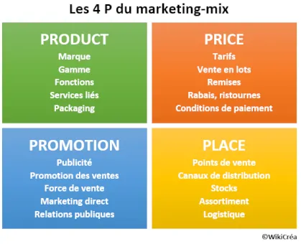

The 4Ps of marketing mix: examples
Here is an example of a marketing mix for the Chanel brand (perfumes) :
- Target: men and women aged 30 and over with above-average incomes
- Product: high quality, know-how, fashion and innovation
- Price: skimming policy
- Promotion: targeted women's magazines, targeted poster advertising, POS advertising
- Distribution: selective distribution strategy (traditional network of city centre perfumeries)
Here is another example of marketing mix for Ryanair (airline company) :
- Target: all travellers within Europe or to countries close to Europe.
- Product: uniform (no comfort class). Numerous additional services, optional and paying
- Price: aggressive penetration policy
- Promotion: mass communication through mainstream media
- Distribution: sale on own website only.
- Delivery times: What delivery times do I offer? What are the delivery terms?
- The target: Who is my service for?
- References and achievements: photos, articles, tastings...

The 4Ps are increasingly challenged by the 4Cs
With the evolution of marketing and modes of consumption, the theory of the 4 P's is increasingly challenged by the theory of the 4 C's: Consumer, Cost, Convenience, Communication :
- The Product is replaced by the Consumer: thinking is increasingly focused on the desires, behaviour and expectations of the customer. The product is increasingly becoming a concept rather than an object with a primary utility.
- Price is replaced by Cost: the client sees the acquisition as a personal cost, without necessarily referring to the prices of the competition,
- Distribution is replaced by Convenience of purchase: the customer is looking for the least possible constraints to acquire and dispose of the product; he is ready to leave the traditional consumption networks to make his life easier,
- Promotion is replaced by Communication: traditional promotion policies must be abandoned for multi-channel communication strategies in order to establish a permanent dialogue with the client.

