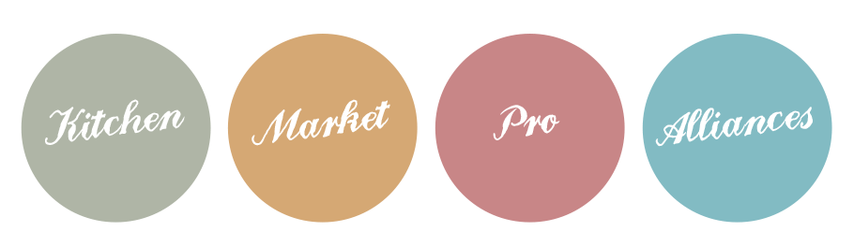
Module 2
Offer sheet

Offer sheet

Client/target/audience | Methodology / Process  - The stages of my service: ……  - The duration of these steps: ……  Supports used  - What media do you work with? .…………………………………………  - What media can be delivered to customers? .…………………………………………  Advantages  - …………………………………………..  - ………………………………………… ..  Sector of intervention  - …………………………………………..  - ………………………………………… ..  Prices  - Methods of payment: ……  - Price: ……

How do I fill in my offer form?
- Technical characteristics: Composition, materials, colour, size, manufacturing standard, etc...
- Commercial features: sliding scale prices, promotion, hygiene guarantees, etc...
- Psychological characteristics: customer references, prices, articles, press...
- Distribution locations: Where do you find my product?
- Production times: How quickly can I prepare my products? And for how many customers? What stocks are available?
- Methodology / Process: What are the main stages of my service? The aim here is to detail my working method and to enlighten my client on the methods (preparation, cooking...) and the raw materials used (local, organic, labels...)?
- The materials used What tools and resources will I use for my performance? (packaging, waiters, delivery staff...) ? What tools will I give to customers? (Menu, dishes, menus, drinks)?
- Duration: How long does it take to prepare my products? Do I also have to detail the duration of the steps?
- Tariffs: How will I charge for my additional service? On a flat-rate basis?
- Price: What is the price of my products? Are there specific prices? Are there commercial offers or offers for a complete service (menu)? Or sliding scale prices?
- Terms and conditions of payment : Is there a deposit with the order? What is the delivery time? What is the payment deadline?
- Delivery times: What delivery times do I offer? What are the delivery terms?
- The target: Who is my service for?
- References and achievements: photos, articles, tastings...

